This homework assignment (plus reading) required 3 h. Question answering from the assignment required 1 h.

**6.9.6)**

The product of a system’s architecture (a document) may convey ‘how’ or ‘what’ capability is achieved by a system. Prior to arriving at a design vision for how a system is to achieve its goals, the predefined goals must be established or agreed upon (regardless of whether refinement is required) to build a model. Approaching the design from the stakeholder perspective such that all ‘viewpoints’ and their inherently defined consequences on the design’s outcome are addressed is possibly more achievable using UML than other languages or representational means to capture a system’s essence. Of stark importance, UML enables a synthesis of understanding among those concerned with development. Although it may not offer capability to model non-functional aspects of a system nor is it a formal representational means compared to others in the ADL- realm, it does support the goals of describing how a system achieves its goal, in the broadest sense, I believe, and this is the position the authors portend in describing what architecture achieves vs. a more constricted view on the subject [pg.209]

**6.9.7)** (Objective: Create two models for Lunar Lander in different notations or from different viewpoint and explain how and why the models are given the consistencies you gave.)

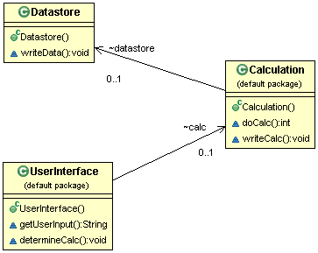

**Figure:** **UML model** of Lunar Landing using the objects-viewpoint (class diagram).

The objects viewpoint used above is the standard notational view of a systems’ classes

(/objects) and is built directly from the code by UML tooling. The UserInterface

association with the Datastore object is maintained as an indirect association in

accordance with the desire to keep concerns separated.

As follows, **a natural language** representation of the Lunar-Lander system is: (Lunar Lander is a spacecraft that is terminating its spaceflight & approaching the landing surface. To do so, 3 structural components facilitate the process.) Structural POV: there are 3 components that exist in the Lunar Lander program: a *display* component ‘handles’ new input data & forwards that along to the *calculator* component, which in turn determines the fuel remaining, possible remaining flight time, current velocity, and distance to the planet’s surface (as a measure relatively determined based on gravitational pull which is written to the data by a source unknown at this level of the structural vantage point); the calculator writes the updated values to the *DataStorage* component after having read the old values out, initially.

In summary, two models of the same viewpoint for the Lunar Lander program are formed. The objective from the developer standpoint was to model the objects relevant to the system implementation, in the context of 3 pre-specified roles (as opposed to all of the potential elements in the system). It was assumed there are/were additional components in the system that are of relevance at an overall architectural level but our concern is with the actors falling under in our domain.

Sensors which collect the data and write it to the database occur in a step that is outside the area of concern for us as well as any hardware-level of remote-networked-in computing or interface capability. The pre-specified roles: ‘User Interface,’ ‘Calculator’ and ‘Datasource’ were modelled as a set of distinctive class objects, in unison with a ‘rough sketch’ **natural language** model provided on page 201, making our derivation of this model easier. Of importance, however, is the notion the developers intended to establish consistency among the two models by ensuring the viewpoints each captured the necessary actions and components in the same context.

While the authors recommend taking a noun-and-verb approach to identify and extract relevant actors to be used in modelling, the approach used was not an extrusion-based modelling but a ground-up modelling considering the actors irrespective of any preconceived notion of the system. The determination in this case was that either model could be reasonably regenerated based on a translating its counterpart.